***Legends of Great Britain***

**The mythology and culture of Great Britain through the legends that have shaped the country's identity.**

When you think of Great Britain, it is impossible not to remember some of its ancient and evocative legends, which have fueled the collective imagination over the centuries.

These stories, passed down from generation to generation, have very deep roots in British culture and represent an important part of the country's history.

Starting from Celtic and Anglo-Saxon mythology, the legends of Great Britain have developed over the centuries, giving rise to a variety of characters and myths.

**King Arthur and the Legend of the Round Table**

Perhaps the most famous legend of Great Britain is that of King Arthur and the Knights of the Round Table.

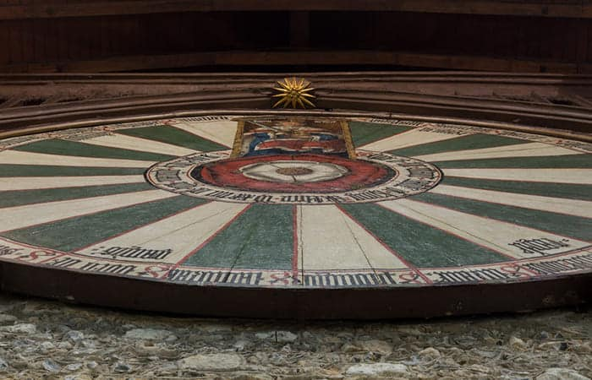The story (which still has no certain sources of its veracity) tells of Arthur as a king who reigned in Britain in the 6th century AD. According to legend, Arthur was a just and brave monarch, who sought to protect his people from barbarian invaders. His court, composed of noble knights, was represented by the famous Round Table, in which all participants were placed on an equal footing.

Even today, the figure of King Arthur is still very present in British culture, through festivals and historical reenactments, such as the Tintagel Festival, held every year in Arthur's supposed birthplace, and the Round Table Parade, which takes place every year in Winchester.

**Robin Hood, the hero of the oppressed**

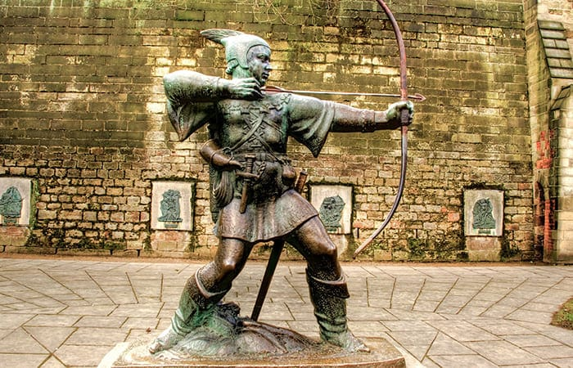Another well-known legend in Great Britain is that of Robin Hood, the hero who stole from the rich to give to the poor. It is said that Robin Hood was a skilled archer who lived in the woods of Sherwood, near Nottingham.

Robin Hood and his fellow outlaws carried out robberies against nobles and rich merchants, then distributed the spoils among the poor.

His image and his deeds are kept alive through festivals and historical reenactments, such as the Robin Hood Fair, held every year in Nottingham.

**The Loch Ness Monster, the never-ending mystery**

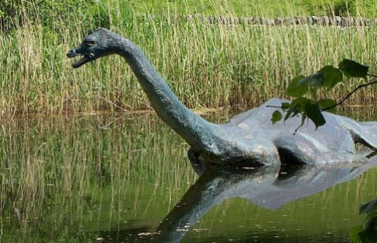One of the most fascinating mysteries of Great Britain is that of the Loch Ness Monster, a legendary creature believed to live in the waters of the lake of the same name, located in the Scottish Highlands.

Legend has it that Nessie, the monster, is a large aquatic animal, similar to a snake, that emerges from the waters of the lake only occasionally.

This myth has attracted the attention of many over time, giving rise to numerous researches and theories on the possible real existence of the creature. Some sightings of the monster have been reported over the years, however no concrete proof of its presence in the waters of the lake has ever been found.

Despite this, the Loch Ness Monster continues to fascinate and the lake in which it is said to be located still attracts many tourists who hope to be lucky enough to spot the legendary creature.

**The Legend of the Dragon of Wales**

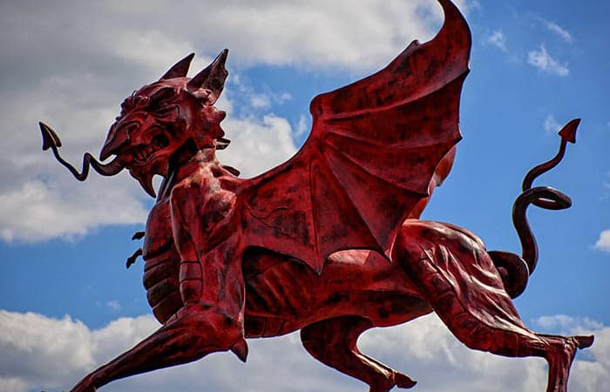The Red Dragon of Wales is one of the most well-known symbols of Wales and has a long history in the folklore of the country.

According to legend, the dragon was chosen as a symbol by King Cadwaladr during the 7th century.

The red dragon is said to represent the Welsh people, while the white dragon represents the Saxons. According to legend, the two dragons fought for supremacy, with the red dragon ultimately winning. The Red Dragon has become a national symbol of Wales, appearing on its flag and being used in many legends, often representing a formidable opponent for the protagonists of the story.

**The Legend of Stonehenge**

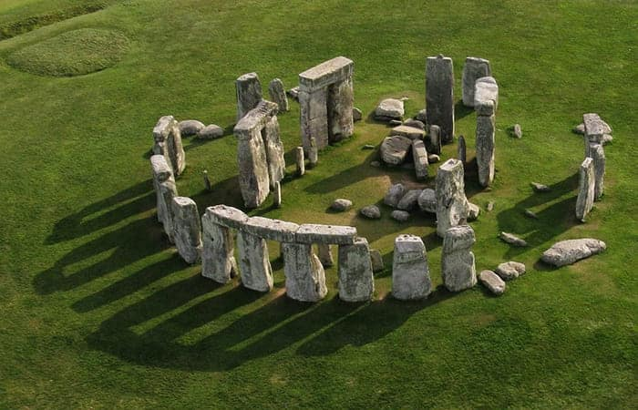Stonehenge, one of the most famous monuments in Great Britain, is at the center of many legends and myths. In fact, after much study and research, it is still not clear how these large stone blocks were transported and erected in the area where they are today.

Legend has it that the megalithic monument was built by giants, or that it was erected by ancient peoples as a place of worship or burial.

Despite the many theories about the origin of Stonehenge, its location and architecture continue to arouse much curiosity and fascination, and the monument attracts thousands of visitors from all over the world every year.

**Other Legends of Britain**

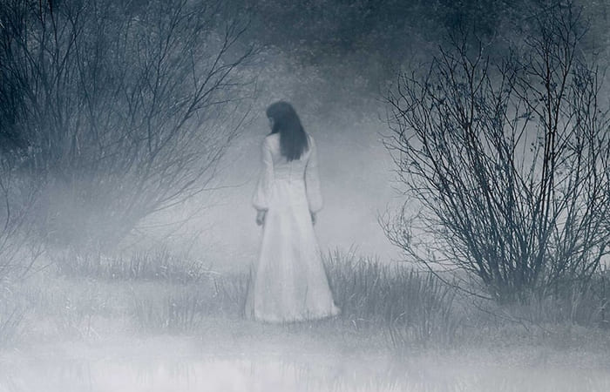The legend of the Ghost of the Tower of London, which tells the story of Anne Boleyn, the second wife of King Henry VIII, who was beheaded in the Tower in 1536, and who is still said to haunt the corridors of the Tower today. The legend of the White Lady, a ghost said to appear in many parts of Britain, often associated with a tragic story or an unfortunate event.

There are actually many versions of the story of the White Lady, but it is generally said that she is a woman who has suffered a violent death and now seeks revenge or justice. The White Lady has become an iconic image of British folklore, and many venture out in search of White Lady haunted locations, often visited as tourist attractions.